Jeff Registre

Project 2: Task 3

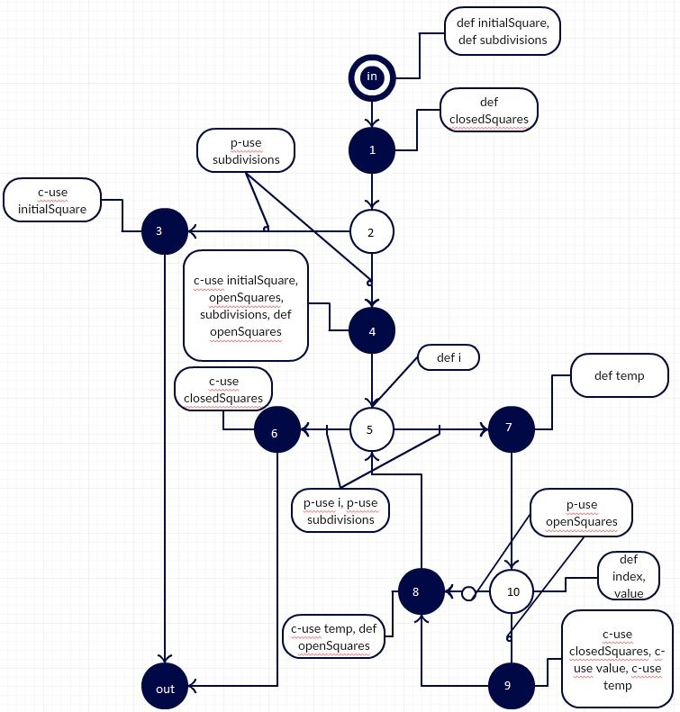

|  |  |  |
| --- | --- | --- |
| Node(n) | Def(n) | C-use(n) |
| In | {initialSquare, subdivisions | { Ø} |
| 1 | {closedSquares} | { Ø} |
| 2 | { Ø} | { Ø} |
| 3 | { Ø} | {initialSquare} |
| 4 | {openSquares} | {initialSquare,subdivisinos, openSquares} |
| 5 | { i} | { Ø} |
| 6 | { Ø} | {closedSquares} |
| 7 | {temp} | { Ø} |
| 8 | {openSquares} | {temp} |
| 9 | { Ø} | {closedSquares,value,temp} |
| 10 | {index,value} | { Ø} |
| out | { Ø} | { Ø} |

|  |  |
| --- | --- |
| **Edge(n,m)** | **p-use(n,m)** |
| (3,4) | {subdivisions} |
| (6,7) | {i, subdivisions} |
| (8,9) | {openSquares} |

|  |  |  |  |
| --- | --- | --- | --- |
| **Node n** | Variable x | DCU(x,n) | DPU(x,n) |
| In | initialSquare | {3,4} | { Ø} |
| In | subdivisions | {4} | {(3,4)} |
| 4 | subdivisions | {4} | {(3,4)} |
| 1 | closedSquares | {6,9} | { Ø} |
| 4 | openSquares | {4} | {(8,9)} |
| 8 | openSquares | {4} | {(8,9)} |
| 5 | i | { Ø} | {(6,7)} |
| 7 | temp | {8} | { Ø} |
| 10 | index | {9} | { Ø} |
| 10 | value | {9} | { Ø} |

|  |  |  |  |
| --- | --- | --- | --- |
| **Path** | **Test id** | **initialSquare** | **subdivisions** |
| 1,2,4,5,7,8,9,10,11,12 | TF1 | Square(0,0,2) | 3 |
| 1,2,3,12 | TF2 | Square(0,0,2) | 1 |

|  |  |  |  |
| --- | --- | --- | --- |
| Path | Test ID | InitialSquare | subdivisions |
| In, 1, 2, 3, out | TF#1 | Square(0,0,2) | 0 |
| In, 1, 2, 4, 5, 6, out | TF#2 | Square(0,0,2) | 1 |
| In, 1, 2, 4, 5, (7, 10, (9)18, 8, 6)2, out | TF#3 | Square(0,0,2) | 3 |